**Sorting:-**

It is mainly of three types :- Selection sort, Insertion Sort, Bubble Sort.

**1.Selection Sorting**

a) From unsorted array find maximum element's position

b)then swap maximum element with last element in unsorted array

0 1 2 3 4 5 6 7

8 1 2 7 6 3 4 5 --> i/p

5 1 2 7 6 3 4 8 p1

5 1 2 4 6 3 7 8 p2

5 1 2 4 3 6 7 8 p3

3 1 2 4 5 6 7 8 p4

3 1 2 4 5 6 7 8 p5 ---- no change

2 1 3 4 5 6 7 8 p6

1 2 3 4 5 6 7 8 p7

0 1 2 3 4 5 6 7

22 11 77 33 44 88 55 23 --> i/p

22 11 77 33 44 23 55 88 p1

22 11 55 33 44 23 77 88 p2

22 11 23 33 44 55 77 88 p3

22 11 23 33 44 55 77 88 p4 ---- no change

22 11 23 33 44 55 77 88 p5 ---- no change

22 11 23 33 44 55 77 88 p6 ---- no change

11 22 23 33 44 55 77 88 p7

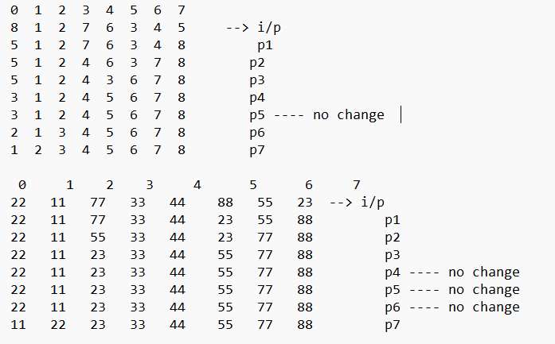

**2.Insertion Sorting**

i = 0 .......... n-1

j = i-1 -------> 0

temp = arr[i] --->

if arr[j] < temp ---> true ---> arr[j+1] = temp , break

false ---> copy arr[j+1] = a[j] j--

j == -1 ---> arr[0] = temp

Example:-

j

--->20 5 10 2 100 50 60 30 22

i

j

--->5 20 10 2 100 50 60 30 22

i

j

--->5 10 20 2 100 50 60 30 22

i

-->temp = 2

--> 5 10 20 20 100 50 60 30 22

--> 5 10 10 20 100 50 60 30 22

--> 5 5 10 20 100 50 60 30 22

--> 2 5 10 20 100 50 60 30 22

j

---> 2 5 10 20 100 50 60 30 22

i

j

---> 2 5 10 20 100 50 60 30 22

i

j

---> 2 5 10 20 50 100 60 30 22

i

j

---> 2 5 10 20 50 60 100 30 22

i

-->temp = 30

--> 2 5 10 20 50 60 100 100 22

--> 2 5 10 20 50 60 60 100 22

--> 2 5 10 20 50 50 60 100 22

--> 2 5 10 20 30 50 60 100 22

j

---> 2 5 10 20 30 50 60 100 22

i

--> temp = 22

-->2 5 10 20 30 50 60 100 100

-->2 5 10 20 30 50 60 60 100

-->2 5 10 20 30 50 50 60 100

-->2 5 10 20 30 30 50 60 100

-->2 5 10 20 22 30 50 60 100

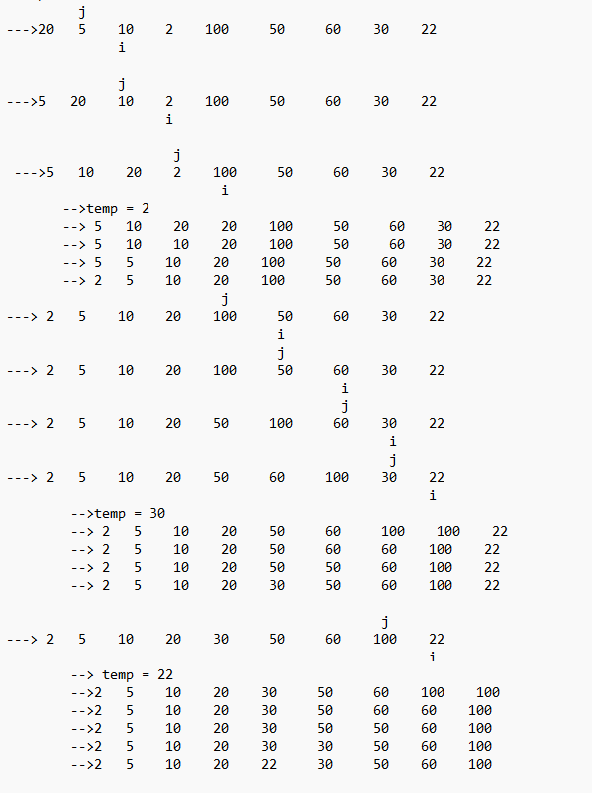

**3.Bubble Sorting**

0 1 2 3 4 5 6 7

---->2 3 1 5 6 7 4 8

--->2 1 3 5 6 7 4 8 p1 sc = 4

--->1 2 3 5 6 7 4 8 p2 sc = 3

--->1 2 3 5 6 7 4 8 p3 sc = 1

--->1 2 3 4 5 6 7 8 p4 sc = 0

0 1 2 3 4 5 6 7

7 5 3 8 2 4 6 1

--->5 3 7 2 4 6 1 8 p1 sc= 6

--->3 5 2 4 6 1 7 8 p2 sc= 5

--->3 2 4 5 1 6 7 8 p3 sc=3

--->2 3 4 1 5 6 7 8 p4 sc=2

--->2 3 1 4 5 6 7 8 p5 sc=1

--->2 1 3 4 5 6 7 8 p6 sc=1

--->1 2 3 4 5 6 7 8 p7 sc=0

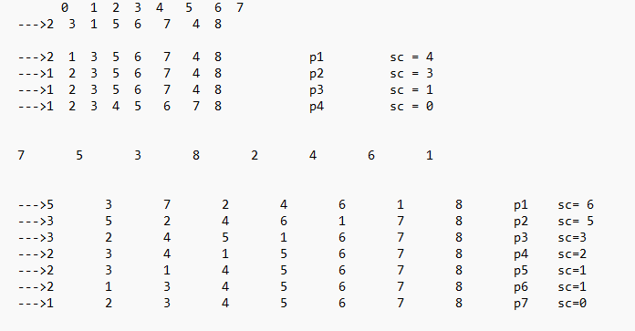

**4.Merge Sorting**

-----> *Merge*

In this we consider two or more sorted arrays in this concept.

arr1 :- 10 20 30 40 50

arr2 :- 2 4 5 7 15 25 30 60 100

Merged array is 2 4 5 7 10 15 20 25 30 30 40 50 60 100

---> set i,j,k=0

---> if A[i]<B[j] --> True

A[i] = C[k]

i++; k++;

False

B[j]= C[k]

j++;k++

---> copy remaining elements of either A or B into Array C

---> If we don't use the following loops after writing the above condition, we get the result as 2 4 5 7 10 15 20 25 30 30 40 50 0 0 i.e; Since we have taken two merged arrays we did't get last two sorted elements

while(j<m)

{res[k]=a2[j];

j++;

k++;}

while(i<n)

{res[k]=a1[i];

i++;

k++;

}

-----> Merge using Insertion

2 5 13 23 25 1 7 9 20 34

0 1 2 3 4 5 6 7 8 9

L M H

Take res =

0 0 0 0 0 0 0 0 0 0

0 1 2 3 4 5 6 7 8 9

i

j

--> 2 5 13 23 25 1 7 9 20 34

0 1 2 3 4 5 6 7 8 9

L M H 2>1

res =

0 0 0 0 0 0 0 0 0 0

0 1 2 3 4 5 6 7 8 9

k

i

j

p1-->2 5 13 23 25 1 7 9 20 34

0 1 2 3 4 5 6 7 8 9

L M H 2<7

res =

1 0 0 0 0 0 0 0 0 0

0 1 2 3 4 5 6 7 8 9

k

i

j

p2-->2 5 13 23 25 1 7 9 20 34

0 1 2 3 4 5 6 7 8 9

L M H 5<7

res =

1 2 0 0 0 0 0 0 0 0

0 1 2 3 4 5 6 7 8 9

k

i

j

p3-->2 5 13 23 25 1 7 9 20 34

0 1 2 3 4 5 6 7 8 9

L M H 13>7

res =

1 2 5 0 0 0 0 0 0 0

0 1 2 3 4 5 6 7 8 9

k

i

j

p4-->2 5 13 23 25 1 7 9 20 34

0 1 2 3 4 5 6 7 8 9

L M H 13>9

res =

1 2 5 7 0 0 0 0 0 0

0 1 2 3 4 5 6 7 8 9

k

i

j

p5-->2 5 13 23 25 1 7 9 20 34

0 1 2 3 4 5 6 7 8 9

L M H 13<20

res =

1 2 5 7 9 0 0 0 0 0

0 1 2 3 4 5 6 7 8 9

k

i

j

p6-->2 5 13 23 25 1 7 9 20 34

0 1 2 3 4 5 6 7 8 9

L M H 23>20

res =

1 2 5 7 9 13 0 0 0 0

0 1 2 3 4 5 6 7 8 9

k

i

j

p7-->2 5 13 23 25 1 7 9 20 34

0 1 2 3 4 5 6 7 8 9

L M H 23<34

res =

1 2 5 7 9 13 20 0 0 0

0 1 2 3 4 5 6 7 8 9

k

i

j

p8-->2 5 13 23 25 1 7 9 20 34

0 1 2 3 4 5 6 7 8 9

L M H 25<34

res =

1 2 5 7 9 13 20 23 0 0

0 1 2 3 4 5 6 7 8 9

k

i

j

p9-->2 5 13 23 25 1 7 9 20 34

0 1 2 3 4 5 6 7 8 9

L M H

res =

1 2 5 7 9 13 20 23 25 0

0 1 2 3 4 5 6 7 8 9

k

i

j

-->2 5 13 23 25 1 7 9 20 34

0 1 2 3 4 5 6 7 8 9

L M H

res =

1 2 5 7 9 13 20 23 25 34

0 1 2 3 4 5 6 7 8 9

k

arr[i] > arr[j] --> true then res[k] = arr[j] j++,k++

-->false then res[k] = arr[i] i++,k++

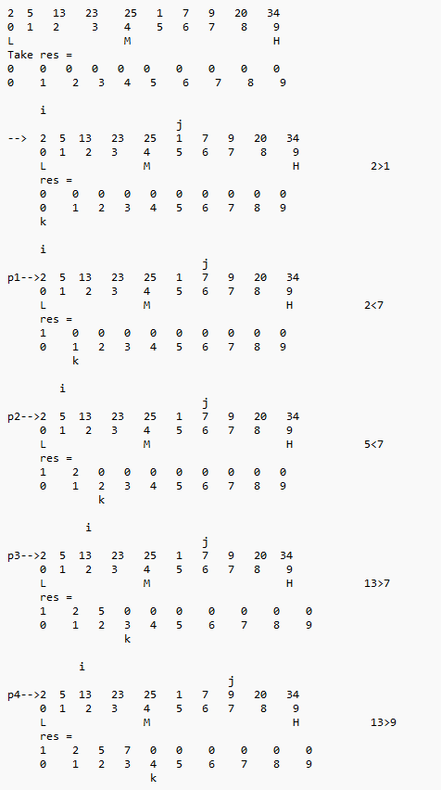

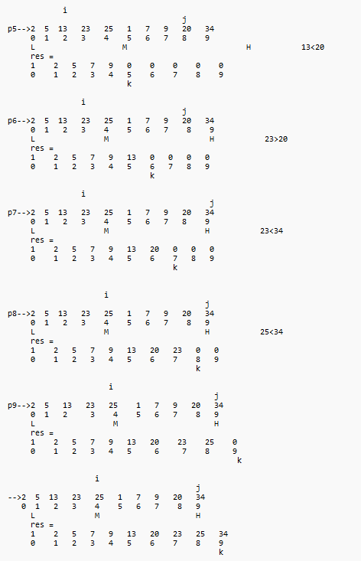

5.Quick Sort:

if arr[i] < arr[p] --> swap(arr[i],arr[j]) i++ j++

False --> i++

swap(arr[j],arr[p])

Here j represents the largest element left to the pivot element